Experience
  - 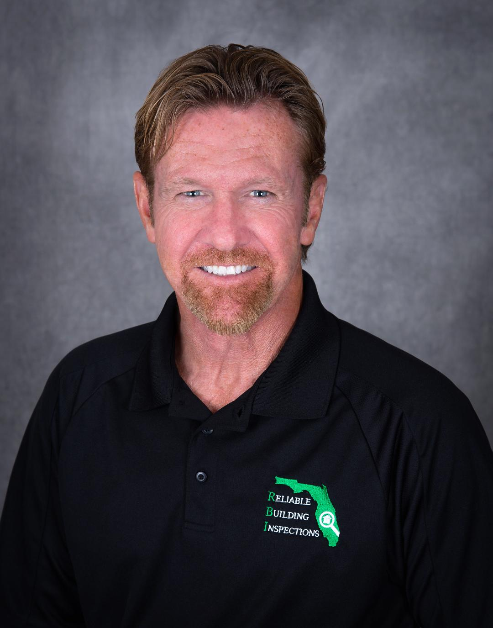

steve rohal
  - Owner & President

Skills & Abilities
Associate Certified Entomologist ACE
Alabama Certified Operator-Wood Destroying Organisms- permit number 2005089
Florida Certified Pest Control Operator including Fumigation and Wood Destroying Organism Inspector and Trainer CF5270
Licensed Home Inspector-FL.
Master Professional Inspector MPI member of both FABI and ASHI
Certified Residential Thermographer (infrared) CRT
Florida Mold Assessor - license number MRSA2893
Extensive public speaking and teaching experience
T 407-837-3892 -direct
E Steve@ReliableBuilding Inspection.com

Reliable Pest & Termite Services, Inc.
  - 9/2005-Current d/b/a RELIABLE BUILDING Inspections
  - Owner/PRESIDENT – Forensic commercial and residential building inspection for structural defect including mold growth, deficient termite treatment and structural termite damage, Licensed Fumigator, wood destroying organism expert, WDO inspection trainer, indoor air quality inspection and testing, Florida licensed mold assessor. OSHA company officer and trainer, Staff Entomologist.

Envirotect Pest Services

8/1992-9/2005
Owner/President- Forensic commercial and residential building inspections, building defect and code/standard compliance including mold growth, licensed fumigator, wood destroying organism (WDO) inspection trainer, indoor air quality inspections and testing. OSHA officer and trainer.
MASSEY SERVICES -General Manager 1990-1992
ORKIN PEST CONTROL- Branch Manager 1980-1990
UNITED STATES AIR FORCE
1976-1980
Member of Base Engineer Emergency Force (Prime BEEF) Rapidly Deployable Civil Engineer Unit

Education

University of Florida -Entomology Studies ACE Program

ENTOMOLOGICAL SOCIETY of AMERICA- ESA

FLORIDA ASSOCIATION OF BUILDING INSPECTORS- Instructor for peer review. Master Professional Inspector #401
SEAK, INC. -Testimony, Deposition, and Expert Witness training
INTERNATIONAL CODE COUNCIL MEMBER ICC
PRO LAB - MOLD IDENTIFICATION and SAMPLING
AMERICAN SOCIETY of HOME INSPECTORS – ASHI member
CERTIFIED PEST CONTROL OPERATORS of FLORIDA- annual CEU training and membership
Orkin Pest Control Branch Manager Training Program -Atlanta, Ga. – graduated at top of class with the President’s Award for Excellence
University of Nebraska at Omaha -1977-1978
Community College of The Air Force -1976 Civil Engineering
Miami Dade Community College -1974-1975

PUBLISHED WORK
Author of the book - Winning the War on Pests! -Tips and Tactics from The Pros
Power Point presentation – ‘Wood Destroying Organism Inspections’

LEADERSHIP
Florida Association of Building Inspectors -peer review instructor
Orkin Management -Presidents Club for Excellence

